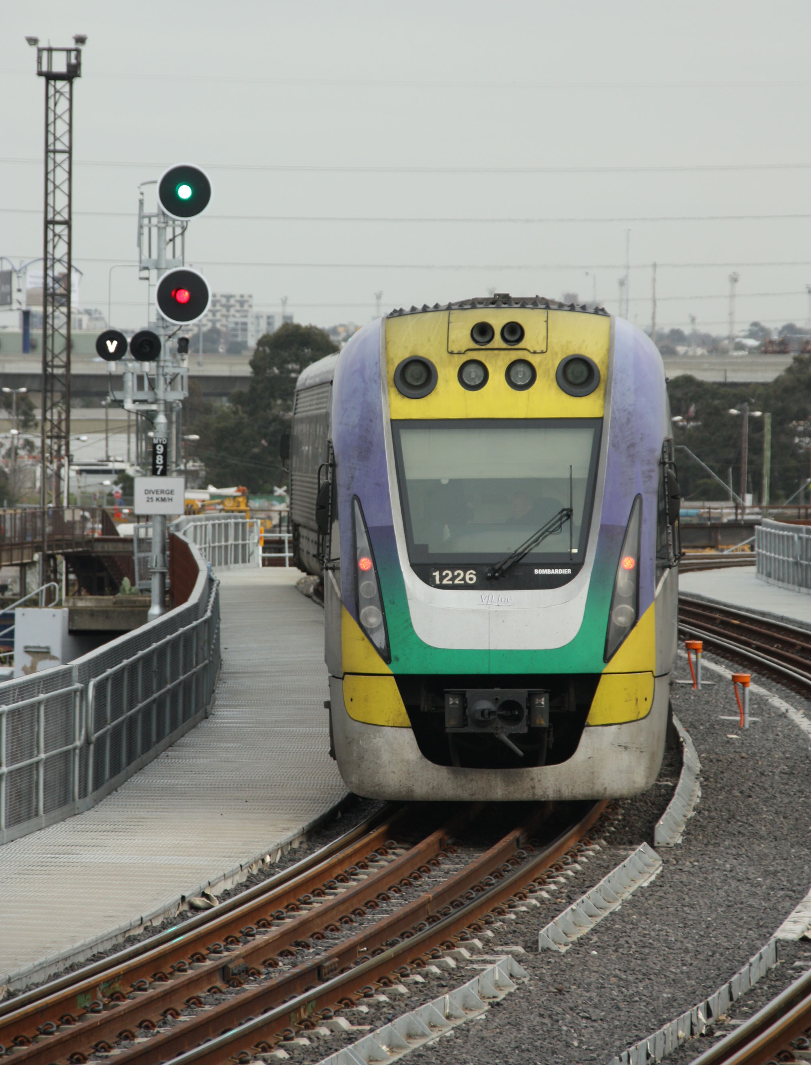SOMERSAULT

September 2014

Vol 37, No 5

Signalling Record Society of Victoria Inc

# Society Contact Information

(Front cover) Down Automatic F441 at Ormond was provided on 21 February 1987 when the line was resignalled in preparation for the provision of the third track between Caulfield and Moorabbin (the three tracks were brought into use on 5 July 1987). The tall lop bracket mast was provided to give a good long view of the signal over the station building on the Down platform, and a co-acting signal was provided to allow a short range view for trains at the platform. Originally the co-acting signal was a pair of incandescent heads identical the main heads. The current LED co-acting signals were provided on 13 May 2005. The main signal heads, however, remain incandescent (as do most on the Frankston line) which is becoming increasingly rare. This signal is likely to be removed within the coming couple of years as the whole station is rebuilt as part of the North Road grade separation. Photo Andrew Waugh

Published by the Signalling Record Society Victoria Inc (A0024029F)

EDITOR: Andrew Waugh, 28 Amelia St McKinnon, VIC, 3204  
Phone (03) 9578 2867 (AH), (03) 9348 5724 (BH), email andrew.waugh@gmail.com

PRESIDENT: David Langley, P.O. Box 8, Avenel, VIC, 3664, Phone (03) 5796 2337

SECRETARY and MEMBERSHIP OFFICER: Glenn Cumming,  
Unit 1/4-6 Keogh St, Burwood, VIC 3125. Phone (03) 9808 0649 (AH)

NSW CONTACT: Bob Taaffe, 63 Hillcrest Rd, Tolmans Hill, TAS, 7007, Phone: (03) 6223 6126

QUEENSLAND CONTACT: Phil Barker  
PO Box 326, Samford, QLD, 4520, Phone: (07) 3289 7177, email: signal-1@bigpond.com

Unless articles use copyrighted information, articles may be reprinted without prior permission but acknowledgment is required. Opinions expressed in articles appearing in SOMERSAULT or supplements are not necessarily those of the S.R.S.V. (Inc.)

# Minutes of Meeting held Friday 16 May, 2014, Surrey Hills Neighbourhood Centre, 1 Bedford Avenue, Surrey Hills

Present: – Noel Bamford, Wilfrid Brook, Glenn Cumming, Graeme Dunn, Michael Formaini, Ray Gomerski, Chris Gordon, Judy Gordon, Bill Johnston, Chris King, Keith Lambert, David Langley, Andrew McLean, Tom Murray, Alex Ratcliffe, Laurie Savage, Brian Sherry, Rod Smith, Andrew Wheatland and Ray Williams.

Apologies: – Jon Churchward, Brett Cleak, Steven Dunne, Steve Malpass, Greg O’Flynn, Trevor Penn, Peter Silva, Stuart Turnbull and Bob Whitehead.

The President, Mr. David Langley, took the chair & opened the meeting at 20:13 hours, following the adjournment of the Annual General Meeting.

Minutes of the March 2014 Meeting: – Accepted as published. Bill Johnston / Rod Smith. Carried.

Business Arising: – Nil.

Correspondence: – Letter from Surrey Hills Neighbourhood Centre advising of change of door code and requesting completion of door code form.

Completed door code form sent to Surrey Hills Neighbourhood Centre.

Alex Ratcliffe / Laurie Savage. Carried.

Reports: – Nil.

General Business: – Glenn Cumming advised that membership renewal forms had been sent and urged members to renew their membership.

Keith Lambert provided details about various works in the Metropolitan District. A summary of the discussion follows: –

The grade separation works at Springvale will be completed over the Easter 2014 weekend.

* New connections to the Sunbury Lines at Sunshine will be commissioned over the June 2014 long weekend.
* New automatic signals for Down trains have been provided at Williams Landing on the Werribee Line.
* The last use of Flemington Racecourse Signal Box will take place at 16:00 hours next Friday. Commissioning of the new signalling on the racecourse line will continue until the long weekend in June 2014. Commissioning of the new signalling between Kensington – Essendon will occur over the long weekend in June 2014.
* New pedestrian gates will be provided at Charman Road, Cheltenham, this weekend and next weekend.
* Caulfield – Moorabbin will be converted to concrete sleepers over the next few months.

Chris Gordon advised that the new timetables that come into use on Sunday 27 July 2014 will include schedules for the RRL Lines between Spencer Street – South Kensington.

The new arrangements at Dunolly were discussed.

Graeme Dunn asked why the new siding at Albion was provided. The answer given was for storing track machines.

Tom Murray described the construction of the new railway station and stabling siding at Grovedale between Marshall and Waurn Ponds.

Chris King described a proposal for grade separation at Glenroy.

Tom Murray advised that a new book on the history of the Redesdale Railway Line will be published soon.

Laurie Savage referred to the recent announcement about future works on the Mildura Line and asked what work had been proposed and what work had been funded.

Chris King asked when the Kilmore – Lancefield Line closed. After some research, the date of closure found was 1 June 1897.

Tom Murray advised that Warncoort Loop is now in service.

Syllabus Item: - The President introduced Member Keith Lambert to present the Syllabus Item.

Keith presented a selection of approximately 25 digital images from Victoria in the form of a “Where is it” type quiz.

The images came from a variety of sources and featured a variety of locations, both country and metropolitan, and from different eras.

The meeting was given ample opportunity to view the images and deduce, estimate or just plain guess the location of each image, with many images receiving appreciative comments.

Noel Bamford and David Langley top scored with a few other members also scoring very well.

The presentation was thoroughly enjoyed by those present at the meeting, probably more for the great collection of images rather than being able to identify all the locations.

At the completion of the Syllabus Item, The President thanked Keith for the entertainment & this was followed by acclamation from those present, along with the promise of a future invitation to do it all again at a future meeting.

Meeting closed at 22:40 hours.

The next meeting will be on Friday 18 July, 2014 at the Surrey Hills Neighbourhood Centre, Bedford Avenue, Surrey Hill, commencing at 20:00 hours (8.00pm).

# Signalling Alterations

The following alterations have come to hand.

16.12.2008 Donnybrook Loop (SN 2487/08)

Between Thursday, 11.12., and Tuesday, 16.12., the crossing loop was extended at the Down end to be 1950 metres in clear.

The Up end points are at 33.572 km and the new Down end points are at 35.756 km. Down Home Departure DBK6 and DBKU6 were replaced by new LED posts at 35.646 km. Up Home Arrival DBK8 was replaced by a new LED post at 35.776 km. The aspects displayed by these signals are unchanged. The Down end cripple road was abolished.

Up Automatic E1288 was replaced by a new LED Automatic E390 at 38.950 km. The aspect displayed by this signal is unchanged.

The Pilot Keys for the Somerton Loop – Donnybrook Loop – Wallan Loop sections were abolished.

Diagram 84/08 (Donnybrook – Wallan) replaced 114/07.

25.11.2009 Wodonga Loop – West Wodonga (SN 2245/09 & SN 2232/09)

Between Monday, 23.11., and Wednesday, 25.11., Wodonga Loop was abolished and West Wodonga was established. The CTC sections will become Chiltern Loop – West Wodonga – (Wodonga Coal Sidings) - Albury. Wodonga Coal Sidings is an intermediate signal box that can be switched in or out. The points and signals at West Wodonga will be controlled via a Phoenix control system by the ARTC Main South C Train Controller at Junee.

Wodonga West.

Crossover 5, which forms a connection between the East and West Lines will be brought into service. The points are equipped with Vossloh-Cogifer point machines. Down Automatics ES2937 & EES2937 (293.700 km), Down Homes WOD6 & WOD18 (296.888 km), and Up Home Departure WOD8 (197.518 km) were provided. Notice Boards were provided at WOD18 (West Line) reading ‘Commence Train Order Working’ (for Up trains) and ‘End Train Order Working’ (for Down trains). Boards lettered ‘West Line’ and ‘East Line’ are provided at the Up end of Crossover 5. The route from WOD8 to the West Line will be inhibited until commissioning of Stage 3.

Predictor operation was provided for the flashing lights at Cochrane’s Rd on both the East and West lines.

Wodonga Loop

Wodonga Loop was abolished, including Points 1, 3, 5, & 7, and Homes WOD2, WOD4, WODU4, WOD6, WODU6, & WOD8. Down Automatic ES9721 was abolished.

Diagram 102/09 (Springhurst – Wodonga) replaced 148/07.

17.12.2009 Ararat, Murtoa, Horsham, Dimboola, Nhill (SN 2594/09, 380/10,)

As from 0000 hours on Wednesday, 17.12., the standard gauge running lines and sidings at these stations were transferred from V/Line to ARTC.

Trains on the Murtoa – Hopetoun and Dimboola – Yaapeet lines will continue to be worked by V/Line Train Control. When it is necessary for trains to access Murtoa or Dimboola it will be necessary for a V/Line signaller to attend.

26.09.2011 Tottenham Loop – Somerton Loop (SN 4877/11)

On Monday, 26.9., control of the standard gauge line between Tottenham Loop and Somerton Loop (inclusive) was transferred from the ARTC Train Controller NCCS Junee to the ARTC Melbourne Metro Board at NCCW Mile End. The section north of SOM/8 is controlled by Junee.

Northbound movements will require Junee to give a release to the Melbourne Metro Board. This will allow the Down Departure Homes at Somerton Loop to be cleared. Similarly, southbound movements will require the Melbourne Metro Board to give a release to Junee, and this will allow the Up Departure Homes at Donnybrook.

26.09.2011 Albion Junction – Jacana Junction (SN 4867/11)

On Monday, 26.9., control of the broad gauge line Albion Junction – Jacana Junction was transferred from the ARTC Train Controller NCCS Junee to the ARTC Melbourne Metro Board at NCCW Mile End.

The following alterations were published in WN 25/14 to WN 25/14 and ETRB A circulars. The alterations have been edited to conserve space. Dates in parenthesis are the dates of publication, which may not be the date of the alterations.

(12.08.2014) Castlemaine (SW 132/14, WN 14)

Operating Procedure 112 (Castlemaine) was issued to cover the movement of trains to and from the Victorian Goldfields Railway, and the maintenance interfaces with that railway.

A crossover is provided between the V/Line tracks and the Victorian Goldfields Railway. Points CME17 in No 2A Track are equipped with a dual control point machine that is electrically secured normal. The points in the VGR are spiked to lay for the VGR. Both points are also secured by a locked point clip with keys being held by the Manager System and Safeworking.

Transfer movements will be under the direct supervision of an Operational and Safeworking Supervisor and will be covered by an Absolute Occupation. Train movements will be conducted by a main line train crew under the direction of a VGR train driver when on the VGR. The VGR driver is to be in possession of the Train Staff for the Maldon line. The Operational and Safeworking Supervisor and a representative of the VGR are to jointly ensure that the crossover is reversed prior to the movement, and is secured normal after the movement has been completed. For movements onto the VGR, the Corridor Signaller will issue a Caution Order to pass Home CME18 at Stop when advised that the points are secured reverse.

21.06.2014 Southern Cross – Franklin St – South Kensington (SW 108/14, WN 25)

On Saturday, 21.6., all tracks on the country side of Southern Cross and the North Melbourne flyover were booked out of service for the RRL reconstruction.

21.06.2014 Nagambie (SW 103/14, WN 24)

On Saturday, 21.6., boom barriers were provided at the passive level crossing at Kirwans Bridge – Longwood Rd (130.377 km). The boom barriers are operated by a level crossing predictor. Trains travelling at more than 50 km/h at the predictor board may accelerate before reaching the crossing. Section 36 predictor boards, healthy state indicators, yellow whistle boards, and remote monitoring will be provided.

22.06.2014 North Melbourne – South Kensington (SW 106/14, 108/14, WN 25)

On Sunday, 22.6., control system upgrades were brought into service for the Up and Down Regional Access lines between the North Melbourne flyover and the RRL Lines. The Melbourne Yard VDU at Centrol was updated. The Regional Access lines remained under absolute occupation. TPWS was commissioned at MYD951, & MYD958, and MW024.

23.06.2014 Melbourne Yard (SW 107/14, WN 25)

On Monday, 23.6., the connection between the South Hump Avoiding track and the dual gauge Freight Link siding was commissioned. Home MYD262 was replaced by a dwarf signal with the same number. Dwarf MYD262 can display stop, low speed warning, and clear low speed. Arrow type route indicators (vertical and left hand) were provided. Points MYD139 were commissioned but were secured normal. The Melbourne Yard VDU at Centrol was updated.

(24.06.2014) Essendon (SW 204/14, WN 25)

The issue concerning the co-ordinated traffic lights at Buckley Street has been resolved. SW 60/14 is cancelled.

26.06.2014 Deer Park West (TON 164/14, WN 27)

On Thursday, 26.6., Points 9 to the Boral Siding were booked out of use.

29.06.2014 Southern Cross, Melbourne Yard (SW 113/14, WN 27)

On Sunday, 29.6., the signal control systems for Melbourne Yard at Centrol and Southern Cross No 1 Box were updated.

29.06.2014 Glenhuntly (SW 216/14, WN 26)

On Sunday, 29.6., the Up approach warning times were altered in preparation for the introduction of Xtrapolis trains. The approaches were extended by reducing the delay times within the existing track circuits. The Up holding approach times will be compliant at 35 seconds.

29.06.2014 Tandara (SW 117/14, WN 27)

On Sunday, 29.6., the siding was (temporarily) placed out of service and the main line points secured normal. The electric detection on the Master Key locks (see SW239/13) has been disabled.

30.06.2014 Elmore (SW 118/14, WN 27)

On Monday, 30.6., the Up end main line points were (temporarily) secured normal. The electric detection on the Master Key lock (see SW72/13) has been disabled. Access to the siding is still available at the Down end.

(01.07.2014) Freight trains on MTM lines (SW /14, WN 26)

Commencing forthwith, all PN grain trains must be followed by a scheduled MTM suburban EMU before a V/Line Velocity service can run.

(01.07.2014) Flemington Racecourse (SW 218/14, WN 26)

Trains are permitted to stable in No 1 Track if all other stabling tracks are occupied or unavailable. The train must be stabled at the Down end of No 1 Track between Home RCE534 and the baulks, and Points 434 must be reversed. SW 2/06 is cancelled.

08.07.2014 Southern Cross – Franklin St – South Kensington (SW 108/14, 109/14, 110/14, 111/14, WN 25)

On Tuesday, 8.7., the North Melbourne flyover was restored to use providing broad and standard gauge access to Southern Cross Nos 1, 2, 2A, and 2B Roads. New broad gauge connections were provided to the RRL lines and South Dynon Loco.

From the RRL lines at Spion Kop Junction a new double track RRL Access Line is provided behind the North Melbourne Arrival Yard to the North Melbourne flyover where a double track junction is provided with the connections to South Dynon Loco and the standard gauge. The North Melbourne flyover was converted to a double track dual gauge line (the former broad gauge access to South Dynon Loco is now the Down line, and the former standard gauge line is the Up line). Franklin St Junction was rearranged, and a double track dual gauge line is provided into Southern Cross.

At the Down (western) end of the North Melbourne flyover a new double track connection to South Dynon Loco has been provided. The former single track connection to the junction of the Reversing Loop (and thence to South Dynon Loco) has been removed. A new dual gauge Freight Link Track (dual gauge headshunt) has been provided from Moonee Ponds Creek Junction, through the site of the former Creek sidings, under the RRL Access Line and North Melbourne Flyover to a connection to the South Hump Avoiding Track.

Southern Cross – Franklin St Junction

The standard gauge line into Southern Cross was converted to dual gauge and will become the Up Dual Gauge line. A new dual gauge line will be provided across the new Dudley St underpass to become the new Down Dual Gauge line, and the former connection to the East Suburban line at the north end of Dudley St was abolished. The Country Line was converted to a bi-directional dual gauge line.

Homes SST507, SST535, SST542, SST572, SST578, SST984, & SST989, Banner Indicators SST572BI & SST578BI and Dwarf SST521 were provided. Points 404 & 421 and Crossovers 401 & 889 were provided. Homes SST572, SST578, SST984, SST989 are fitted with TPWS. Dwarf SST521 is fixed at Stop.

Homes SST182, SST184, SST501, SST506, SST530, SST540, SST580, 521, 525, 531, & 532, and Dwarfs SST544, 500, 501, 503, & 504 were abolished.

All these points and signals are worked from No 1 Box.

Franklin St Junction – Spion Kop Junction via North Melbourne flyover

The double track Dual Gauge Line was provided over the North Melbourne flyover. The broad gauge double track Regional Access Line was provided from the Down (western) side of the flyover to the RRL lines at Spion Kop Junction.

Homes MYD955, MYD980, MYD982, MYD985, & MYD987, and Automatic MF022 were provided. Points 483, 882, & 887 and Crossover 476 were provided. Points 854 & 855 at Spion Kop Junction were brought into use. Home ADL218 was renumbered MYD576. Homes MYD576, MYD955, MYD980, MYD982, MYD985, & MYD987 are equipped with TPWS.

All these points and signals, except MYD955 and Points 854 & 855 at Spion Kop Junction, are worked from No 1 Box. Home MYD955 and Points 854 & 855 are worked from the RRL panel at Centrol.

An emergency road access has been provided across the Regional Access Line for emergency or oversize vehicles. The access gates are detected and released by the Signaller No 1 Box.

Dwarf MYD284 has been abolished.

South Dynon Loco Access

The Down Flyover and Up Flyover Tracks were brought into use. The direct connection to the Reversing Loop from the flyover was abolished.

Home MYD581 and Dwarfs MYD186 & MYD188 were provided. Dwarf MYD190 was renumbered MYD582. For moves from Dwarf MYD582 a released from No 1 Box is required. Points 481 (MYD) & 484 (MYD) and Crossover 482 (MYD) were provided. Points 203 (MYD) and Crossover 199 (MYD) were provided with dual control point machines. The notice board on the Up Engine Track at South Dynon Loco for departing movements has been altered to read “Trains proceeding to MYD582 are to obtain permission from the RRL Train Controller Centrol”.

All these points and signals are worked from Centrol.

Dwarfs MYD184, MYD194, MYD284, & MYD286 have been abolished. Points 201 were abolished.

Moonee Ponds Creek Junction

ARTC controls the points and signals at Moonee Ponds Creek Junction, including Home MPJ206. When it is necessary to signal a Down standard gauge train towards Moonee Ponds Creek Junction, the Signaller at No 1 Box must obtain permission from the ARTC Train Controller and may then set the route and clear Down Home MYD987. Home MYD987 will display a running low speed aspect while MPJ206 is at stop. When it is necessary to signal an Up standard gauge train towards the Flyover, the ARTC Train Controller is to confer with the Signaller at No 1 Box. The Signaller will reverse Points 483, and this will allow the ARTC Train Controller to clear the signal for the movement (Dwarfs MPJ208 or MPJ210 or Home MPJ212).

Freight Link Track

Dwarfs MYD262 & MPJ218 were provided. Points 219 (MPJ) were provided. For moves from Dwarf MYD262 to the Freight Link Track a release from ARTC is required. For moves from Dwarf MPJ218 to the South Hump Avoiding Track a release from Centrol.

Dwarf MPJ218 and Points 219 are worked by ARTC. Dwarf MYD262 is worked by Centrol.

SW 2/14 and 70/14 are cancelled.

12.07.2014 Southern Cross – Franklin St (SW 108/14, 122/14, 206/14, SWP 8/14, WN 25, 26, 28)

On Saturday, 12.7., Franklin St Junction was simplified and control altered. Franklin St Junction was divided into a suburban side (the Through Suburban, Main Suburban, and East Suburban Lines) controlled by Metrol, and a country side controlled from No 1 Box. Only the Main Country and Through Country lines now have access to the Suburban lines at Franklin St. Redundant points and signals from the East Line were removed. A new single track (bi-directional) Country Bypass line was provided to give direct access between the flyover lines and Nos 7, 8, and 8A Roads. This replaced the former Carriage Sidings No 8 & 10.

Franklin St Junction – Metrol side

Up Home 546 (East Suburban Line) was abolished. Points 412, 414, 416, & 447, Crossovers 439 & 446 and Catch 412 were abolished. Posts 524, 543, 545, 562, & 564 were converted to LED. The illuminated letter ‘A’ was removed from Homes 520, 524, 541, 543, 545, 560 & 564. Theatre route indicators were provided on Homes 516 and 556 and will display ‘M’ for Metropolitan and ‘R’ for Regional lines.

Franklin St Junction – No 1 Box side

Homes SST442, SST500, SST525, SST527, & SST533, and Dwarfs SST502 & SST575 were provided. Home SST500 is fitted with TPWS. Points 406, 410, 435, & 463, Crossover 423?, and Hayes Derail/Crowder 463 were provided. Points 429, 432, 434, 436, 439, 470, & 471 were provided with dual control point machines.

Control of the points and signals at the Down end of No 7 North Road was transferred to No 1 Box. Cross boundary interfaces are provided between Metrol and No 1 Box for the following moves:

* Suburban lines and the Main Country Line (Up direction only) at Franklin St Junction
* Suburban lines and the Through Country Line (in both directions) at Franklin St Junction
* Suburban lines and No 7 Road (in both directions)
* Country Bypass Line and Nos 8 and 8A Roads (in both directions)

Metro Trains Operating Procedure 12 (Metrol – Southern Cross No 1 Signal Box, Failure of signals at the cross boundary interface) was reissued.

Upon completion of the alterations, Diagrams 70/14 (Southern Cross V/Line Passenger Lines), 68/14 (Southern Cross MTM Passenger Lines), 74/14 (Southern Cross – North Melbourne Passenger Lines), 72/14 (West Tower – Melbourne Yard), 78/14 (Moonee Ponds Creek), and 66/14 (South Kensington) replaced 92/13, 14/14, 90/13, 94/13 (West Tower), 96/13, & 20/14 respectively.









10.07.2014 Tottenham Yard (TON 187/14, WN 30)

On Thursday, 10.7., No 4 West Road was booked out of service.

12.07.2014 North Melbourne Flyover (TON 175/14, WN 28)

At 1518 hours on Saturday,12.7., the Up and Down Dual Gauge North Melbourne Flyover Tracks and the Up and Down Regional Access Tracks were booked out of use due to derailment damage. Points 484, 854, & 855 were secured normal, and Points 889 were secured reverse.

(15.07.2014) Operation of road rail vehicles and track machines on Metro network (SWP 9/14, WN 28)

SWP 2/14 was reissued due to the removal of Kensington signal box from the list of locations where the signaller directly controls the level crossing.

(15.07.2014) Spencer Street (SW 228/14, WN 28)

Due to an overlap issue, Home 529 (No 8 Centre) will only display Low Speed Caution for the move to Home 507. The Signaller Metrol will be required to select the low speed function after the route has been set.

(15.07.2014) Melbourne Yard (SW 124/14, WN 28)

The broad gauge connection between the Freight Link Track and the South Hump Avoiding Track is not available for use. Points 139 have been secured normal. SW109/14 has been cancelled and new instructions will be issued.

17.07.2014 Broadmeadows (SW 230/14, WN 28)

On Friday, 18.7., Dwarf BMS532 and the insulated rail joint at the Up end of Siding C were relocated 6 metres in the Down direction. Siding C is now 459 metres in length. Amend Diagram 51/10 (Glenbervie – Somerton).

19.07.2014 Kensington – Essendon (SW 235/14, 236/14, WN 29)

On Saturday, 19.7., alterations were made to the Kensington and Essendon interlocking data to correct the following issues:

* Route line not dropping out for signals KEN551, KEN596, & NKT553
* Stopping/Express selection at Moonee Ponds to be selected from timing track at Strathmore
* Modify the Stopping/Express selection at Buckley St, Essendon, when signals are in partial fleeting mode.
* Modify the approach locking condition for signal KEN551
* Modify Macaulay Rd approaches for Up trains
* Provide R/Y (Medium Speed Warning) aspect on E340 with forward route set

The signalling restriction involving ESD544 (SW 221/14) is cancelled.

20.07.2014 Broadmeadows (SW 231/14, SWP 10/14, WN 29)

On Sunday, 20.7., train compound security gate 431 was motorised and interlocked with the signal system.

Metro Trains Northern Group Operating Procedure 17 (Craigieburn, Somerton, Broadmeadows Failure of Signals) is to be amended to include a new clause I “Broadmeadows C Siding Train Stabling Compound Gates”.

(22.07.2014) Essendon & Flemington Racecourse Line (SW 207/14, 208/14, WN 29)

Amend the Working Timetable Addenda to reflect the resignalling of Essendon and the Flemington Racecourse Line.

31.07.2014 Kilmore East – Broadford (SW 129/14, WN 30)

On Thursday, 31.7., the flashing lights at Dry Creek Rd (70.960 km) were converted to boom barriers. Operation will continue to be by predictors. Trains travelling at more than 50 km/h at the predictor boards may increase speed before reaching the level crossing. RFR Predictor Indicator Boards were provided and the existing Predictor Boards were abolished. Healthy State and Yellow whistle boards were provided.

Amend Diagrams 66/13 (Heathcote Junction – Kilmore East) and 22/12 (Broadford – Tallarook).

02.08.2014 Metrol (SW 249/14, WN 30)

The TCMS facility will assume the Metrol signalling and train control functions between 0300 hours Saturday 2.8.14 and 0300 hours Tuesday 5.8.14.

(05.08.2014) Frankston – Stony Point (SW 252/14, WN 31)

Under no circumstances is a single unit Sprinter to operate between Frankston and Stony Point. All movements are to operate as multiple unit consists.

End£

# VR Signal Box Diagrams

Chris Guy and Wilfrid Brook

The signal box diagram is provided to ensure that the signaller has a constant awareness of the track layout and signals he/she is responsible for and serves as an adjunct to the efficient operation of the interlocking frame.

Traditional signal box diagrams fall into two categories – illuminated and picture frame. Illuminated diagrams were usually provided in track circuited locations to display the movement of trains within the track sections controlled by the signal box. This type of diagram first appeared at South Yarra in 1915. It featured fully illuminated track sections and was housed in a heavy, riveted metal casing. The larger examples were suspended from the ceiling on large hooks and were most impressive. At least twenty-six of these were eventually to be found at various city and suburban signal boxes and two still survive in service at Brighton Beach (Figure 1) and Sandringham at the time of writing (June 2014).

In 1925 a more austere type of illuminated diagram featuring bullseye lamps within each heavily drawn track section and housed in a timber casing was introduced. Examples could be found in both suburban and country locations such as Dendy Street (Figure 2) and Violet Town. Apart from a few nondescript diagram types being produced in the interim, for example South Yarra, a new concept in illuminated diagrams was introduced during the 1940s. This type featured watercoloured track sections with small lamps in each section and was seen, for example, in service at Little River (Figure 3).

The first Victorian Railways interlocking was brought into use on 1 July 1876 at Essendon Junction, North Melbourne (1) and picture frame diagrams possibly date from this time. On p. 42 of the book “The Signal Box” is a photograph of the interior of Lydney Junction Great Western box taken in 1879 which shows a signal box diagram (2). Signal box diagrams are mentioned in the Minutes of the Engineer of Existing Lines – the forerunner of the Victorian Railways Way and Works Branch – in about 1885 (3). The information they display has changed little since then.

The size of the diagram usually relates directly to the extent of the location it represents. Drafting styles are of particular interest. Some of the earliest diagrams at Ballarat East and Bendigo C (Figure 4) survived until the 1980s and were quite artistic and unique. This style of drafting gave way to a more contemporary form early in the second decade of the last century. The former Baxter and Greensborough (Figure 5) diagrams typified the style. Even so certain features, such as the depiction of the signal box as a hatched box, lingered on until the style which eventually became standard was adopted, for example Glenrowan (Figure 6). This arrangement using standard symbols consists of the track layout with all associated signals, points, lock bars, gates and any other controlled equipment suitably numbered according to the lever which operates it. Signal lever numbers are shown in red beside the relevant signal, point lever and lock bar lever numbers are shown in black. Point numbers in picture frame diagrams and some illuminated diagrams were circled which distinguished them from lock bar numbers. All signalled moves are set out under the heading of either Up signals or Down signals depending upon the direction of movement within the area of control. Below the operating room of the signal box can be found the interlocking apparatus with safeguards against conflicting moves being set up. Thus the levers can only be pulled in a particular sequence.

The layout of track and signals in the diagram had to be such that it could be readily understood without confusion. Most diagrams assumed a rectangular (landscape) configuration with track and signals drawn above the Up and Down moves. However in some cases this standard format was varied due to the need to depict unusual track layouts, for example Northcote Loop Junction (Figure 7), where the signalled moves were set out on the right hand side of the track diagram.

Close examination of certain diagrams produced in the Victorian Railways drawing office will reveal to the attentive eye the superb penmanship of one particular draftsman who drew a large number of diagrams – both picture framed and illuminated – over a period of at least twenty years. None of this person’s contemporaries ever managed to equal his style. Sadly, some of the very last diagrams drawn could only be described as amateurish – perhaps reflecting the modern day loss of drafting skills formerly employed.

When one examines diagrams of Flinders Street A (Figure 8), B and C Boxes or No 1 Box Melbourne Yard it is difficult to appreciate the vast amount of time involved in laying out the details in pencil and completing the job in black permanent ink and red watercolour thickened with gum Arabic. One has to admire the results the draftsman achieved with tools of trade that are now considered obsolete. Because of their size and the danger of damaging such a large piece of cartridge paper, these diagrams - and others - were linen backed for strength and durability.

Alterations to diagrams were usually carried out in the drawing office at Spencer Street and a reduced photograph provided in the signal box in lieu. There were occasions when simple alterations were effected on site –especially when patches were placed over moves which no longer applied and the corresponding features on the diagram were either erased or simply patched over. The Signal and Telegraph Engineer would put his name to a newly drafted diagram or one that had been altered. The Interlocking Engineer initialled and dated the diagram below the lower margin.

Three known types of timber mouldings were used in the manufacture of picture frames over the years until the last was issued to service in the 1970s.

The abolition of interlocked frames over more recent years and the introduction of control panels complete with engraved track and signal layouts have virtually brought to an end the era of hand drafted diagrams. Those that

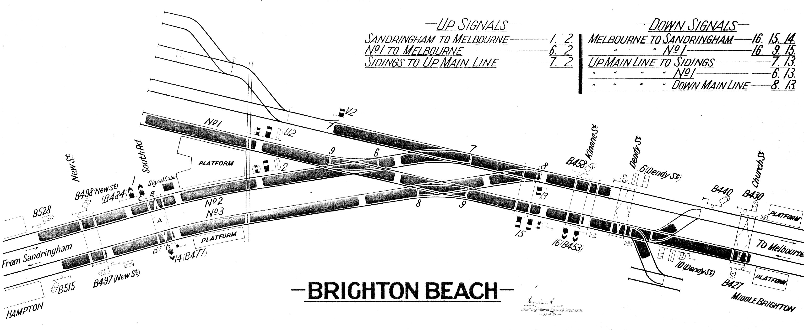

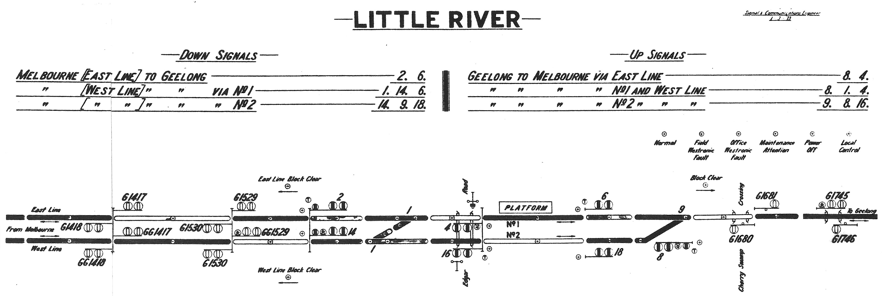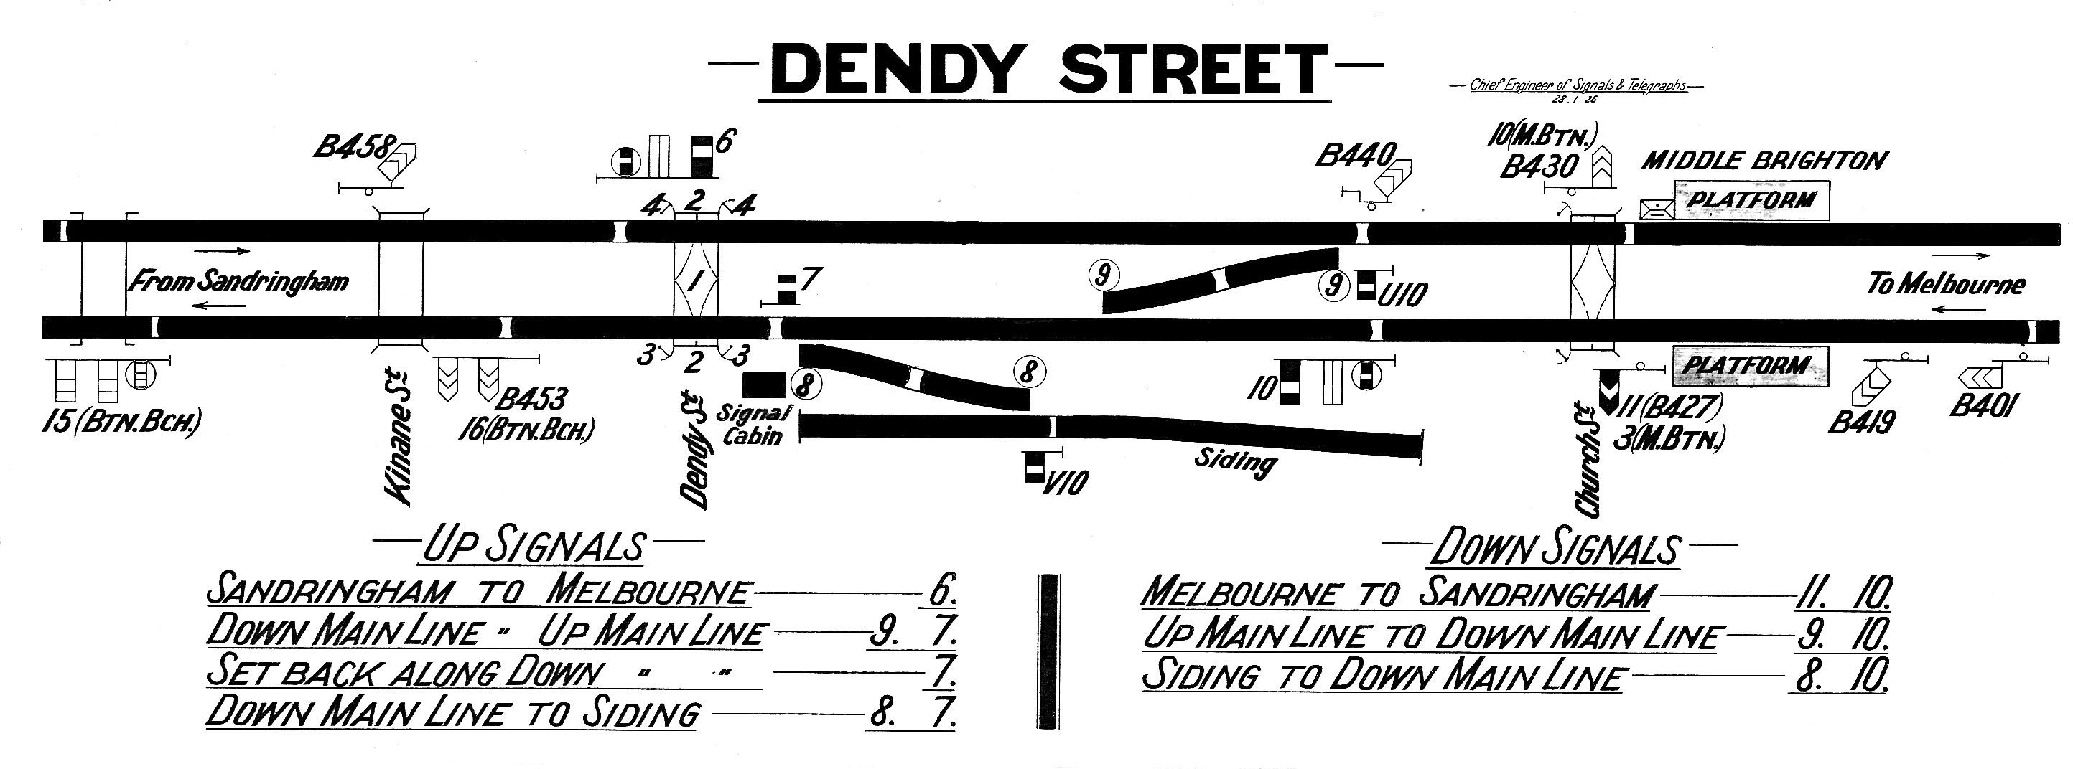

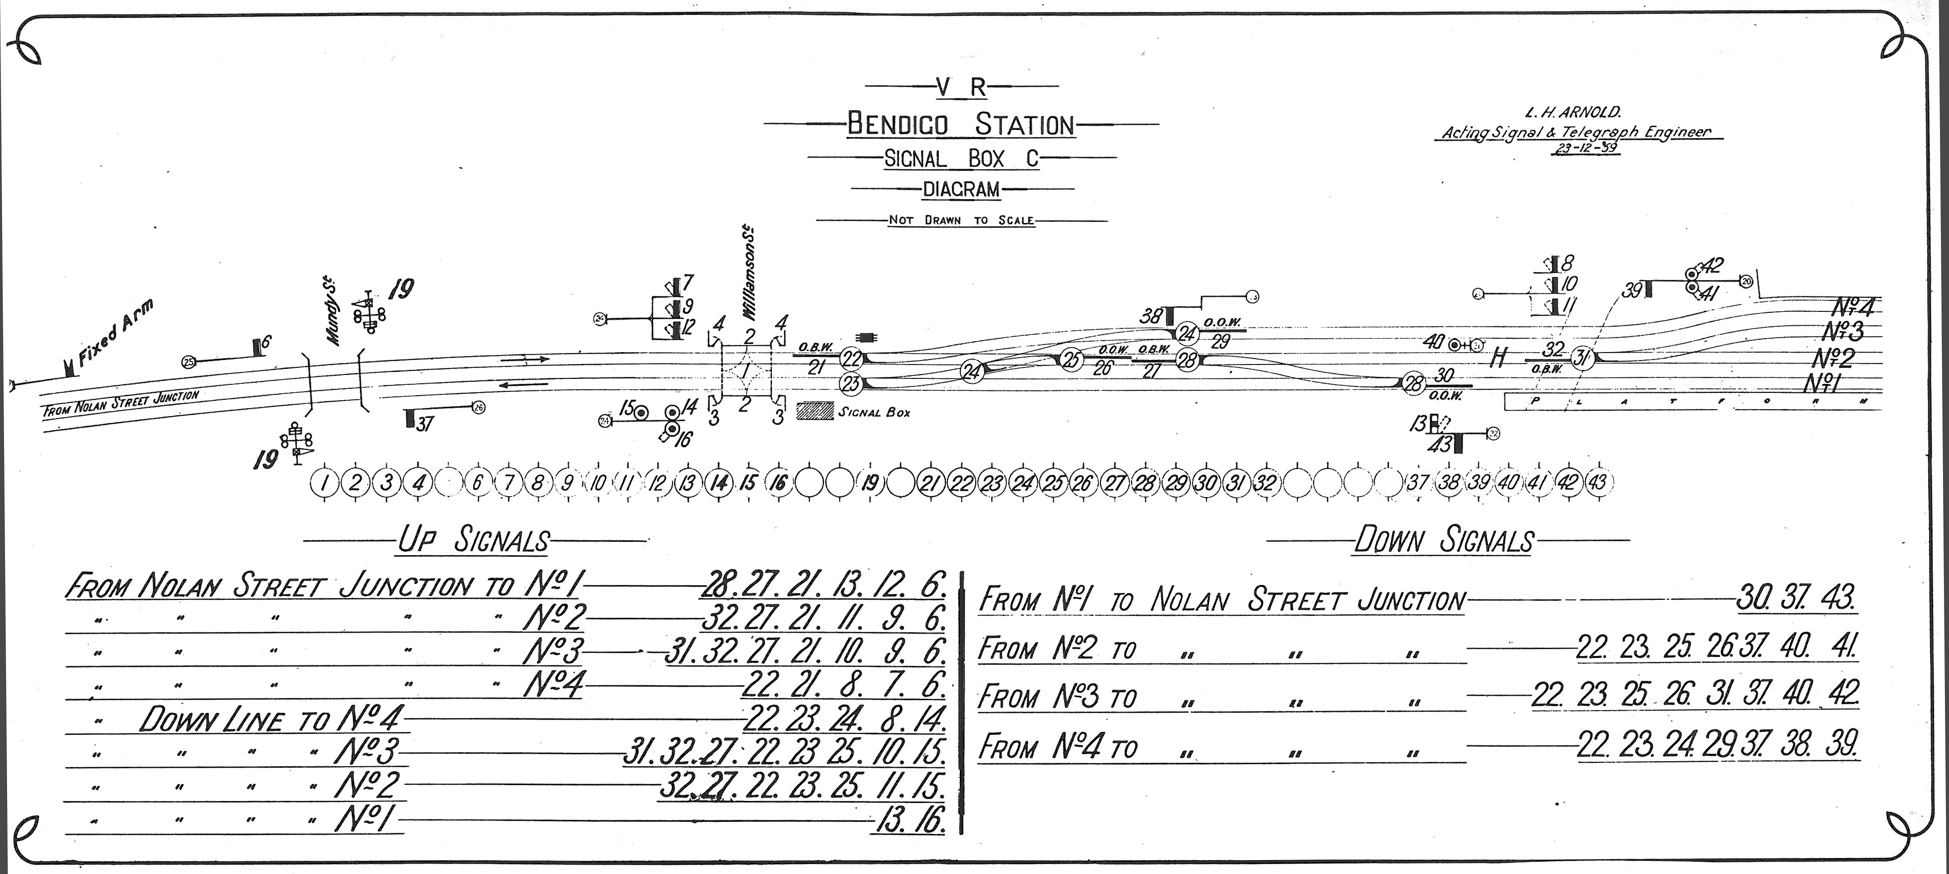

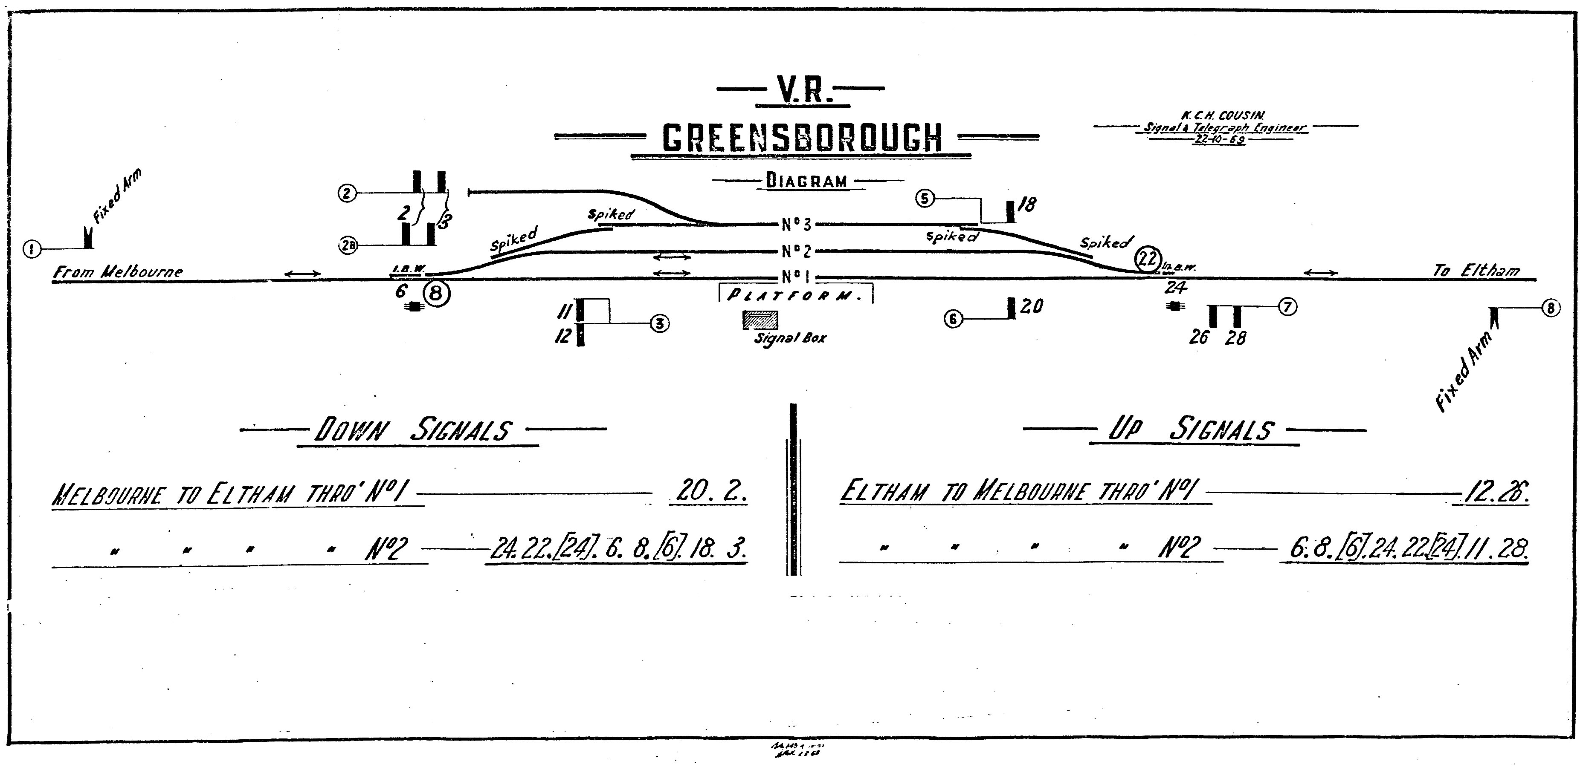

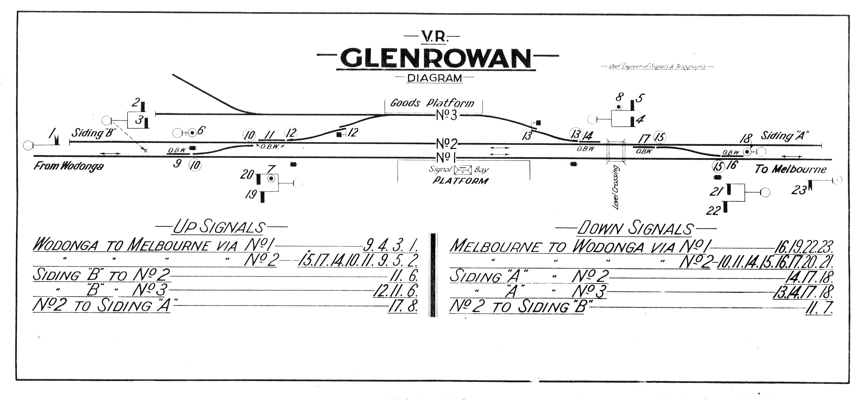

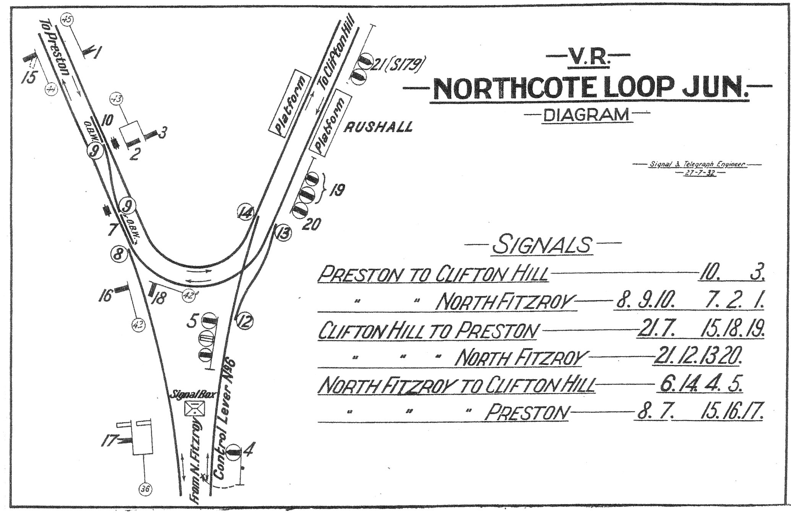

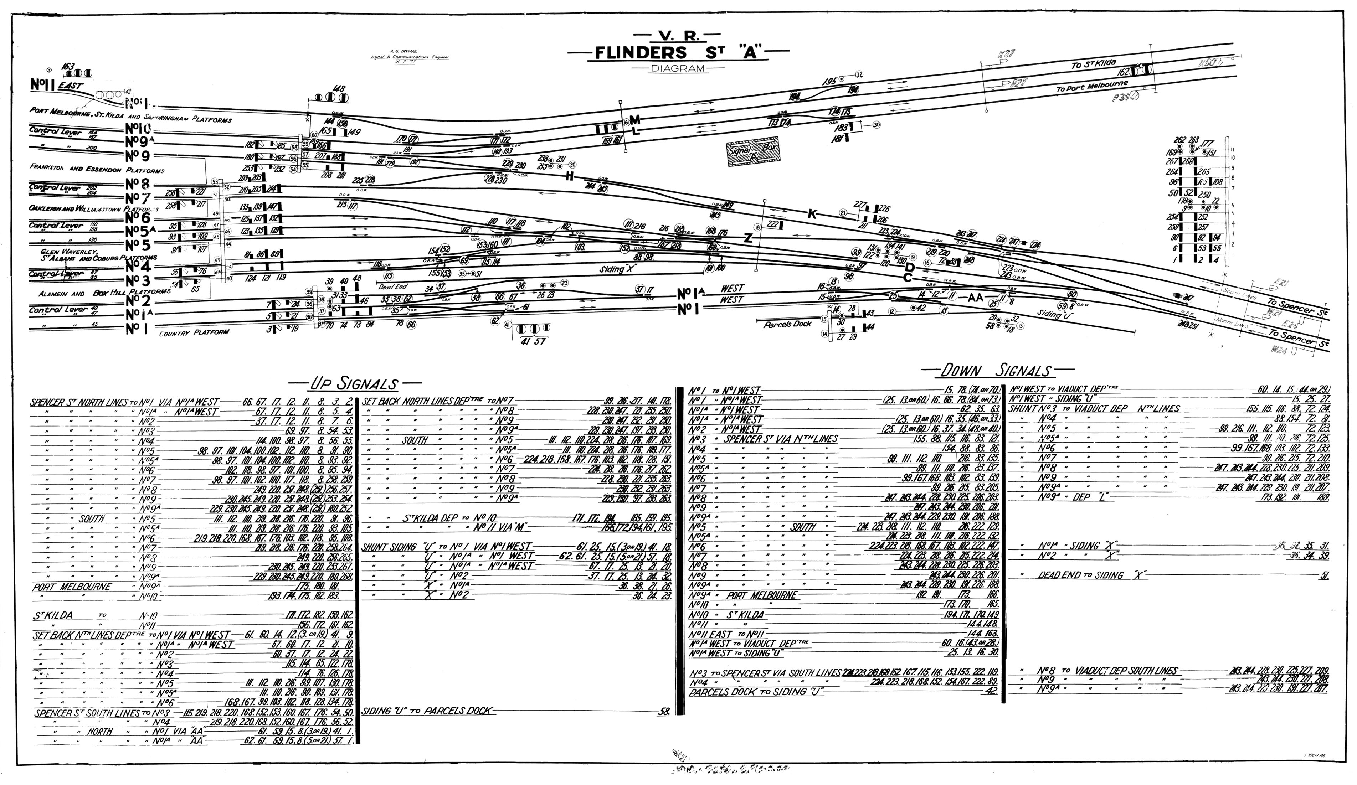

survive in private collections are highly prized, for they represent a significant chapter in the history of railway signalling. In June 2007 a diagram of the South Australian Railways 1886 “Balhannah Station Yard – Diagram of Points and Signals” sold for $810 at auction (4).

## References.

1. The Argus, Monday 3 July 1876.

2. The Signalling Study Group. The Signal Box. A Pictorial History and Guide to Designs. Oxford Publishing Company, 1986, p. 42.

3. Michael Guiney. Personal communication.

4. The End of the Line Mail Auction No. 9, 22 June 2007